ISSN: 2456-8090 (online)
DOI: 10.26440/IHRJ/0609.12553

Understanding Prescribing Cascades: Evaluating Risks and its Management

MOHITA CHADHA ¹, JAISMINE SINGH *¹

Cite this article as: Chadha M, Singh J. Understanding Prescribing Cascades: Evaluating Risks and its Management. Int Healthc Res J. 2022;6(9):RV4-RV7. https://doi.org/10.26440/IHRJ/0609.12553

Author Affiliations:
- Interns, Department of Public Health Dentistry, Himachal Dental College, Sundernagar. (https://orcid.org/0000-0002-4229-4081, Mohita Chadha, https://orcid.org/0000-0001-9275-7892, Jaismine Singh)
Contact Corresponding Author at: singhjaismine911[at]gmail[dot]com
ABSTRACT
Prescribing cascade occurs when an adverse drug event is misinterpreted as a new medical condition resulting in a new medication being prescribed to treat the adverse drug event. A simple example is prescription of a proton pump inhibitor(PPIs) to counteract the acid reflux caused by non-steroidal anti-inflammatory drugs(NSAIDs). An interconnection between polypharmacy and prescribing cascade is established where both have a direct influence on each other. Prescribing cascade can affect people of any age but has shown to frequently affect the elderly patients. Assessment tools include both simpler ways like effective communication, clinical process mapping, NO TEARS checklist and complex algorithms like the Screening Tool for Potentially Inappropriate Prescriptions (STOPP), Beers criteria, Medication Appropriateness Index. Identifying and disrupting the prescribing cascade is an important, feasible, and undervalued opportunity to improve patient drug safety.

KEYWORDS: Prescribing Cascade, Polypharmacy, Adverse Drug Event, Elderly Patients, Deprescribing.

INTRODUCTION
Quality healthcare delivery is majorly governed by medications. Irrational prescription of medication poses a huge menace to health systems across the world causing poor health care delivery and wastage of scarce resources. Globally, the risk of adverse events associated with drugs has consistently been observed to increase with the increasing burden on the healthcare system.¹ Prescribing errors affects more than 1.5 million people per year and results in at least 1,90,000 hospital admissions annually.² The ongoing failure to address the problem of medication related adverse events that cause patient harm is on spike. Compounding this, the misinterpretation of the adverse event to a new symptom initiates a cascade of events resulting in polypharmacy. This dynamic needs to be addressed with high priority for patient safety.
What is prescribing cascade?
Prescribing cascade occurs when an adverse drug event is misinterpreted as a new medical condition resulting in a new medication being prescribed to treat the adverse drug event. The idea of prescribing cascade was first described by Rochon and Gurwitz in 1995.³ This prescription of the new drug can be intentional or unintentional. An example to quote is prescription of a proton pump inhibitor(PPIs) to counteract the acid reflux caused by non-steroidal anti-inflammatory drugs(NSAIDs).² These cascades of events are likely to be seen in older patients with multimorbidity, patients with multiple medical conditions managed by multiple subspecialist physicians and patients having chronic mental health conditions.^{4,5} Prescribing cascade also highlights an important area of concern- problematic polypharmacy.
Polypharmacy has no precise definition. It is described as administration of multiple drugs to a patient.⁶ From over-the-counter drugs to a prescribed medication, every medicine comes with side effects. More the number of drugs administered to a patient, higher are the chances of misinterpretation of an adverse drug reaction (ADR) as a new medical condition. Hence, the direct interconnection between polypharmacy and prescribing cascade is established. Prescribing cascades resulting from both known and unknown ADR jeopardises the patient.²
Risk factors for prescribing cascade
Prescribing a medication is a complex decision making event including close consideration of various factors. Misinterpretation of any event puts the patient into the dangers of polypharmacy. Polypharmacy is directly associated with higher incidence of ADRs which may provide opportunities for prescribing cascades to occur(3). Patient-related risk factors mainly include older patients with multimorbidity, patients with chronic conditions and having multiple sub specialty physicians, those residing in assisted living facilities, psychologically ill patients and younger patients primarily with heart disease, diabetes, stroke and cancer.⁵ Looking through the sex and gender lens, women are at greater risk for ADRs than men.⁷
Elderly population is at higher risk of prescribing cascade than the younger population.⁸ In a cohort study, a diuretic was prescribed to counteract the ankle edema caused by calcium channel blockers in 9.5% of elderly patients.⁹ Another well recognised example of prescribing cascade in elderly population is symptoms arising from use of drugs like antipsychotics or metoclopramide. This leads to initiation of antiparkinson therapy. According to a case-control study of 3512 patients aged 65 to 99 years, antiparkinson therapy was likely to be prescribed 5.4 times more to patients who had received antipsychotics in the past 90 days.⁸
Irrational prescribing of drugs, poor communication between physician and patient, poorly maintained medical records and automated refill systems are some of the contributing factors for prescribing cascade.^{1,2,5} High proportions of patients report that they are not explained the side effects of the prescribed medication¹⁰, hence, they fail to identify an ADR. Approximately 15% of patients stop treatment due to an ADR without the physician's consultation. Updated medical records of patients among different sub specialty physicians is necessary to prevent prescribing cascade.

Commonly reported drugs in prescribing cascade(Table 1)
The commonly reported drugs in prescribing cascade is described in table 1.

Assessment tools for prescribing cascade (Figure 2)
Real time identification of prescribing cascades is a challenging task. Simpler ways like mass communication among the population regarding the side effects of medications to facilitate better communication with their physicians. There are tools to assist clinicians with deprescribing of drugs and to ensure quality prescribing like the Screening Tool for Potentially Inappropriate Prescriptions (STOPP) and Beers criteria, as well as implicit measures such as the Medication Appropriateness Index. The NO TEARS checklist informs clinicians the importance of addressing polypharmacy. Clinical process mapping is another simple yet efficient way of preventing prescribing cascade and promoting deprescribing wherever necessary. It is a process that can be done in an inpatient or outpatient setting, at the bedside while interviewing the patient, or after a clinical encounter.^{4,14}
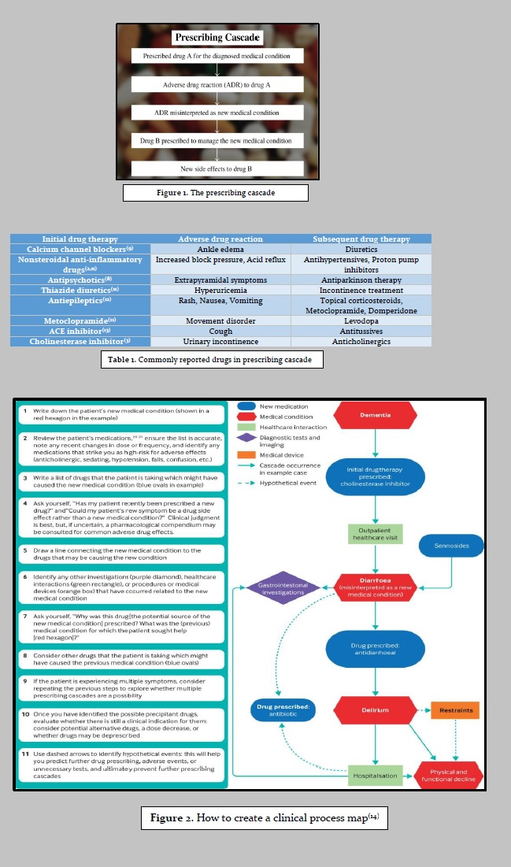
Alternate link to tables/figures (Copy/paste link in a new browser window): https://drive.google.com/file/d/1ui-miBE5fvoK9JuMfQCepVty0ycdJjKG/view?usp=sharing
How to prevent prescribing cascade
The therapeutic benefit of medication should be weighed well against the harmful effects for patient safety. As prescribing cascade is precipitated by ADRs, early detection of an ADR can be helpful in preventing the cascade. This can be done by patient education to improve awareness regarding the potential side effects of new medications. Educational interventions can be done by seminars, print media or face-to-face contact.¹
Documenting response to therapy can help the clinician to assess whether the new symptom is a response to medication or actually a new condition. Most ADRs occur due to high dosage of medication, starting therapy at low doses and periodic evaluation will reduce the risk of ADRs.² Clinicians should consider deprescribing wherever necessary. Deprescribing should be viewed as initiating a “therapeutic intervention” similar to initiating clinically appropriate therapy. Furthermore, health-care systems should adopt streamlined approaches to medication tracking, this might help identify potential medications for deprescribing and reduce physician, staff, and patient burden.⁵ Non-pharmacological approaches should be considered before drug therapy.
The Trial of Nonpharmacologic Interventions in the Elderly (TONE) suggested that lifestyle modifications and reduced sodium uptake reduced need for antihypertensive therapy in about 40% of the intervention group.⁸
A systematic approach to prescribing should include: clearly define the patient’s problem, setting the therapeutic objectives, patient education regarding the benefits and risks of the therapy, periodic review of drug therapy, discontinuing unnecessary medications, considering non-pharmacologic alternative strategies; considering safer alternative medications; using the lowest possible effective dose; including all necessary beneficial medications.^{8,15}
CONCLUSION
Prescribing cascade is an increasingly common problem in medical practice. Futile polymedication results in polypharmacy which not only presents major health risks but also raises various ethical and economical issues.
Clinicians should implement ways for cascade detection and secondary prevention. This should include mindful practice and rational prescribing of drugs. Identifying and disrupting the prescribing cascade is an important, feasible, and underappreciated opportunity to improve patient drug safety.
REFERENCES
- Ofori-Asenso R, Agyeman A. Irrational use of medicines—a summary of key concepts. Pharmacy. 2016;4(4):35.
- Kalisch LM, Caughey GE, Roughead EE, Gilbert AL. The prescribing Cascade. Australian Prescriber. 2011;34(6):162–6.
- Trenaman SC, Bowles SK, Kirkland S, Andrew MK. An examination of three prescribing cascades in a cohort of older adults with dementia. BMC geriatrics. 2021;21(1):1-1.
- Doherty A, Moriarty F, Boland F, et al. Prescribing cascades in community-dwelling adults: protocol for a systematic review. HRB Open Research. 2021;4:72.
- Halli-Tierney A, Scarbrough C, Carroll DG. Polypharmacy: evaluating risks and deprescribing. American family physician. 2019;100(1):32-8.
- Guillot J, Maumus-Robert S, Bezin J. Polypharmacy: A general review of definitions, descriptions and determinants. Therapies. 2020;75(5):407-416.
- Rochon PA, Petrovic M, Cherubini A, Onder G, O'Mahony D, Sternberg SA, et al. Polypharmacy, inappropriate prescribing, and deprescribing in older people: Through a sex and gender lens. The Lancet Healthy Longevity. 2021;2(5):e290-300.
- Rochon PA, Schmader KE. Drug prescribing for older adults. Toronto: UpToDate. 2019.
- Sternberg SA, Guy-Alfandary S, Rochon PA. Prescribing cascades in older adults. Canadian Medical Association Journal. 2021;193(6).
- Schoen C, Osborn R, Huynh PT, Doty M, Davis K, Zapert K, et al. Primary care and health system performance: Adults' experiences in five countries. Health Affairs. 2004;23(Suppl1).
- Rochon PA, Gurwitz JH. Optimising drug treatment for elderly people: The prescribing cascade. BMJ. 1997;315(7115):1096–9.
- Tsiropoulos I, Andersen M, Hallas J. Adverse events with use of antiepileptic drugs: A prescription and event symmetry analysis. Pharmacoepidemiology and Drug Safety. 2009;18(6):483–91.
- Vegter S, de Jong-van den Berg LT. Misdiagnosis and mistreatment of a common side-effect - angiotensin-converting enzyme inhibitor-induced cough. British Journal of Clinical Pharmacology. 2010;69(2):200–3.
- Piggott KL, Mehta N, Wong CL, Rochon PA. Using a clinical process map to identify prescribing cascades in your patient. BMJ. 2020;:m261.
- Pollock M, Bazaldua OV, Dobbie AE. Appropriate prescribing of medications: an eight-step approach. Am Fam Physician. 2007;75(2):231-6.
© Mohita Chadha. This is an open access article distributed under the terms of the Creative Commons Attribution License CC-BY-NC 4.0, which permits unrestricted use, distribution and reproduction in any medium, provided the use is not commercial and the original author(s) and source are cited.
Submitted on: 13-Nov-2022; Accepted on: 02-Dec-2022

